**DATABASE MANAGEMENT SYSTEM**

**23CCE212**

**TERM PROJECT – 209**

**STUDENT DATA MANAGEMENT SYSTEM**

**Submitted by:**

**JAYANTH C R**

**CB.EN.U4CCE23018**



Department of Electronics and Communication Engineering,

Amrita School of Engineering, Amrita Vishwa Vidyapeetham,

Coimbatore, India -641112.

**ABSTRACT:**

The Student Data Management System is a comprehensive solution designed to simplify and enhance the management of student information in educational institutions. Built using HTML, CSS, and JavaScript for the frontend and MySQL for the backend, the system provides a secure, role-based interface for administrators, staff, and students. It includes features for managing departments, courses, student records, hostel allocations, transportation services, fee tracking, and extracurricular activities. The platform links students and faculty to department and course details, maintains detailed student profiles, and efficiently handles hostel assignments, room allocations, and transport for day scholars. Financial operations like tuition, bus, hostel, and mess payments are tracked in real time, ensuring transparency and accuracy. Additionally, the system monitors students’ participation in sports and extracurricular activities, maintains their academic records, and simplifies leave management through an organized pass request system. With a strong database design that ensures data security and scalability, the system is capable of handling the growing needs of institutions. By automating tasks and centralizing data, the Student Data Management System improves operational efficiency, reduces the workload on administrators, and enhances the experience for all users, making it a reliable and effective tool for managing institutional data.

**Objectives:**

**1.Centralized and Efficient Data Management:**

* Combines all student-related data into a single, secure platform to reduce redundancy and improve data consistency across departments.

**2.Automation and Process Optimization:**

* Automates essential tasks like fee tracking, hostel allocations, course enrollments, and academic records management, saving time and minimizing errors.

**3.Role-Based Access Control:**

* Ensures secure and role-specific access for administrators, staff, and students, safeguarding sensitive information while improving data privacy.

**4.Comprehensive Student and Institution Services:**

* Supports features like department and course management, student profiles, hostel and transport services, fee payments, and extracurricular activity tracking.

**5.Transparency and Enhanced Communication:**

* Promotes transparency by providing real-time data access and improving communication through notifications, announcements, and role-specific dashboards.

**6.Improved User Experience:**

* Offers a user-friendly, accessible interface with features designed to meet the needs of all stakeholders, ensuring operational efficiency and a seamless experience.

**Interface:**

The Student Data Management System UI, built with PHP, CSS, and MySQL, provides a responsive, user-friendly, and role-specific experience. Personalized dashboards for administrators, staff, and students streamline access to features like academic records, payments, and notifications.

With intuitive navigation, clean aesthetics, and dynamic forms and tables, the system ensures efficient data management. A secure, role-based login system offers tailored access, while real-time alerts and visual analytics improve engagement and decision-making. This design prioritizes usability, efficiency, and a seamless experience across all devices.

**Scope:**

The scope of the Student Data Management System project includes the development of a centralized, efficient, and user-friendly platform for managing student-related data in educational institutions. The system will handle key processes such as department and course management, student profiles, fee tracking, hostel allocation, and extracurricular activity monitoring.

Using PHP and CSS for the frontend and MySQL for the backend, the system will offer role-based access for administrators, staff, and students, ensuring secure and tailored access to functionalities. It will automate manual processes, reduce redundancy, improve accuracy, and enhance transparency in data handling.

**ENTITY – RELATION DIAGRAM:**

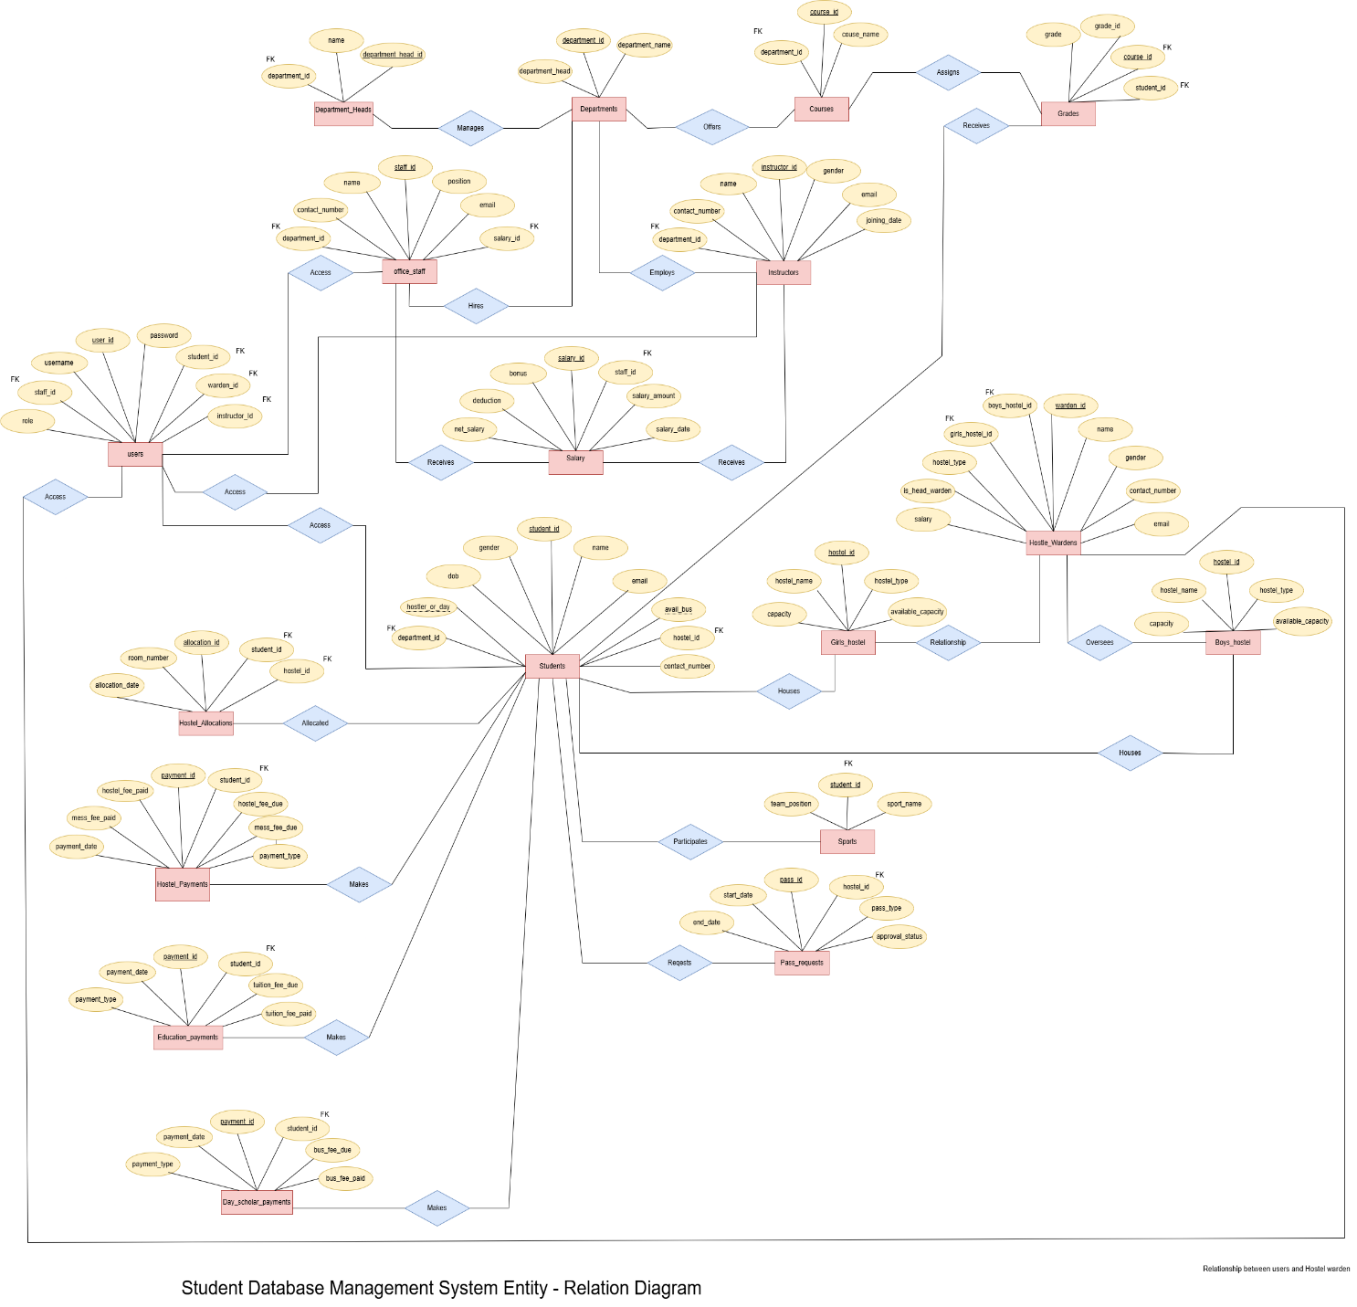

**SCHEMA DIAGRAM:**

